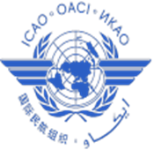

International Civil Aviation Organization

THE FIRST MEETING OF ASIA/PACIFIC ATS INTER-FACILITY
DATA-LINK COMMUNICATION (AIDC) IMPLEMENTATION
TASK FORCE (APA TF/1) OF APANPIRG

Bangkok, Thailand, 16 -18 June 2015

Agenda Item xx: Select appropriate agenda concerned to propose WPs, IP from WP/1 – Provisional Agenda

TITLE IN CAPITAL

(Presented by Name of State/Organization)

SUMMARY

This paper presents WRITE BRIEF OVERVIEW SUMMARY HERE, SHOULD NOT BE LONGER THAN 100 WORDS

- INTRODUCTION

  - TEXT

  - TEXT

- DISCUSSION

  - TEXT

  - TEXT

  - TEXT

- ACTION BY THE MEETING

  - The meeting is invited to: AMEND AS APPROPRIATE

              - note the information contained in this paper; and

              - discuss any relevant matters as appropriate.

_ _ _ _ _ _ _ _ _ _ _ _ _

